Quinn Knudsen

Homework 7

Topic: **Measures of association**

3)

> cor.test(rock$area,rock$perm)

Pearson's product-moment correlation

data: rock$area and rock$perm

t = -2.9305, df = 46, p-value = 0.005254

alternative hypothesis: true correlation is not equal to 0

95 percent confidence interval:

-0.6118206 -0.1267915

sample estimates:

cor

-0.396637

The results here indicate that there is a significant negative relationship between rock area and rock permeability so that as rock area increase permeability increases (p<.05). The 95% confidence interval spans -0.6118206 -0.1267915. This does not cross the threshold of zero indicating significance. This correlation is moderate.

4)

> bfCorTest <- function (x,y) # Get r from BayesFactor

+ {

+ zx <- scale(x) # Standardize X

+ zy <- scale(y) # Standardize Y

+ zData <- data.frame(x=zx,rhoNot0=zy) # Put in a data frame

+ bfOut <- generalTestBF(x ~ rhoNot0, data=zData) # linear coefficient

+ mcmcOut <- posterior(bfOut,iterations=10000) # posterior samples

+ print(summary(mcmcOut[,"rhoNot0"])) # Get the HDI for rho

+ return(bfOut) # Return Bayes factor object

+ }

> bfCorTest(rock[,"area"],rock[,"perm"])

|============================================================================================================================| 100%

|----|----|----|----|----|----|----|----|----|----|

**************************************************|

Iterations = 1:10000

Thinning interval = 1

Number of chains = 1

Sample size per chain = 10000

1. Empirical mean and standard deviation for each variable,

plus standard error of the mean:

Mean SD Naive SE Time-series SE

-0.344000 0.135383 0.001354 0.001512

2. Quantiles for each variable:

2.5% 25% 50% 75% 97.5%

-0.61048 -0.43322 -0.34268 -0.25255 -0.08021

Bayes factor analysis

--------------

[1] rhoNot0 : 8.072781 ±0%

Against denominator:

Intercept only

---

Bayes factor type: BFlinearModel, JZS

A similar negative relationship is found using the Bayesian methodology with a 95% HDI falling between -.61 and -0.08 and a rhoNot0 ratio of 8.07.

8)

> UCBAdmissions[,,1]

Gender

Admit Male Female

Admitted 512 89

Rejected 313 19

> chisq.test(UCBAdmissions[,,1])

Pearson's Chi-squared test with Yates' continuity correction

data: UCBAdmissions[, , 1]

X-squared = 16.372, df = 1, p-value = 5.205e-05

The results here provide grounds to reject the null hypothesis that the admittance between males and females is the same (*x*²= 16.37, df=1, p<.05). From the contingency table, we can see the proportion of females admitted is higher than the proportion of males admitted.

9)

> ctBFout <- contingencyTableBF(UCBAdmissions[,,1],sampleType="poisson",posterior=FALSE)

> ctBFout

Bayes factor analysis

--------------

[1] Non-indep. (a=1) : 1111.64 ±0%

Against denominator:

Null, independence, a = 1

---

Bayes factor type: BFcontingencyTable, poisson

This output signifies nonequivalence between the ratio of males and females selected therefore providing support to reject the null hypothesis that the two groups are equivalently admitted. The Bayes factor here is 1111.64:1 favors the alternative hypothesis with pretty strong evidence for nonequivalence.

10)

> ctMCMCout <- contingencyTableBF(UCBAdmissions[,,1],sampleType="poisson",posterior=TRUE,iterations=10000)

> summary(ctMCMCout)

Iterations = 1:10000

Thinning interval = 1

Number of chains = 1

Sample size per chain = 10000

1. Empirical mean and standard deviation for each variable,

plus standard error of the mean:

Mean SD Naive SE Time-series SE

lambda[1,1] 511.01 22.441 0.22441 0.23071

lambda[2,1] 312.66 17.531 0.17531 0.17531

lambda[1,2] 89.75 9.360 0.09360 0.09412

lambda[2,2] 19.95 4.455 0.04455 0.04455

2. Quantiles for each variable:

2.5% 25% 50% 75% 97.5%

lambda[1,1] 467.83 495.74 510.64 526.14 555.28

lambda[2,1] 279.23 300.74 312.23 324.12 348.31

lambda[1,2] 72.26 83.29 89.44 95.92 108.74

lambda[2,2] 12.26 16.81 19.64 22.67 29.66

> maleProp <- ctMCMCout[,"lambda[1,1]"]/ctMCMCout[,"lambda[1,2]"]

> mean(maleProp)

[1] 5.756205

> femaleProp <- ctMCMCout[,"lambda[2,1]"]/ctMCMCout[,"lambda[2,2]"]

> mean(femaleProp)

[1] 16.48759

> diffProp <- maleProp - femaleProp

> hist(diffProp)

> mean(diffProp)

[1] -10.73139

> abline(v=quantile(diffProp,c(0.025)), col="black")

> abline(v=quantile(diffProp,c(0.975)), col="black")

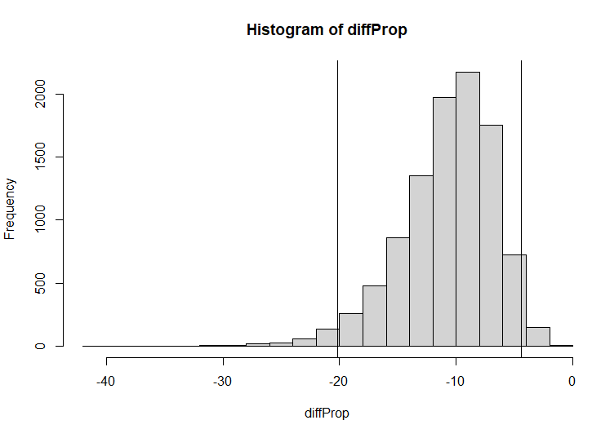

The results here indicate that when calculating the difference between the two genders, the 95% HDI of the difference falls between -20 to -4 with females having a higher ratio of acceptance.